**OUTPUT OF THE ATTACHED CODES**

**Name : HEMANG PRAKHAR**

**Roll No : R164218027**

**SAP ID : 500067006**

**CSE IoT B1**

**RTOS LAB -1**

1. **Print the memory map of the system using the C code.**

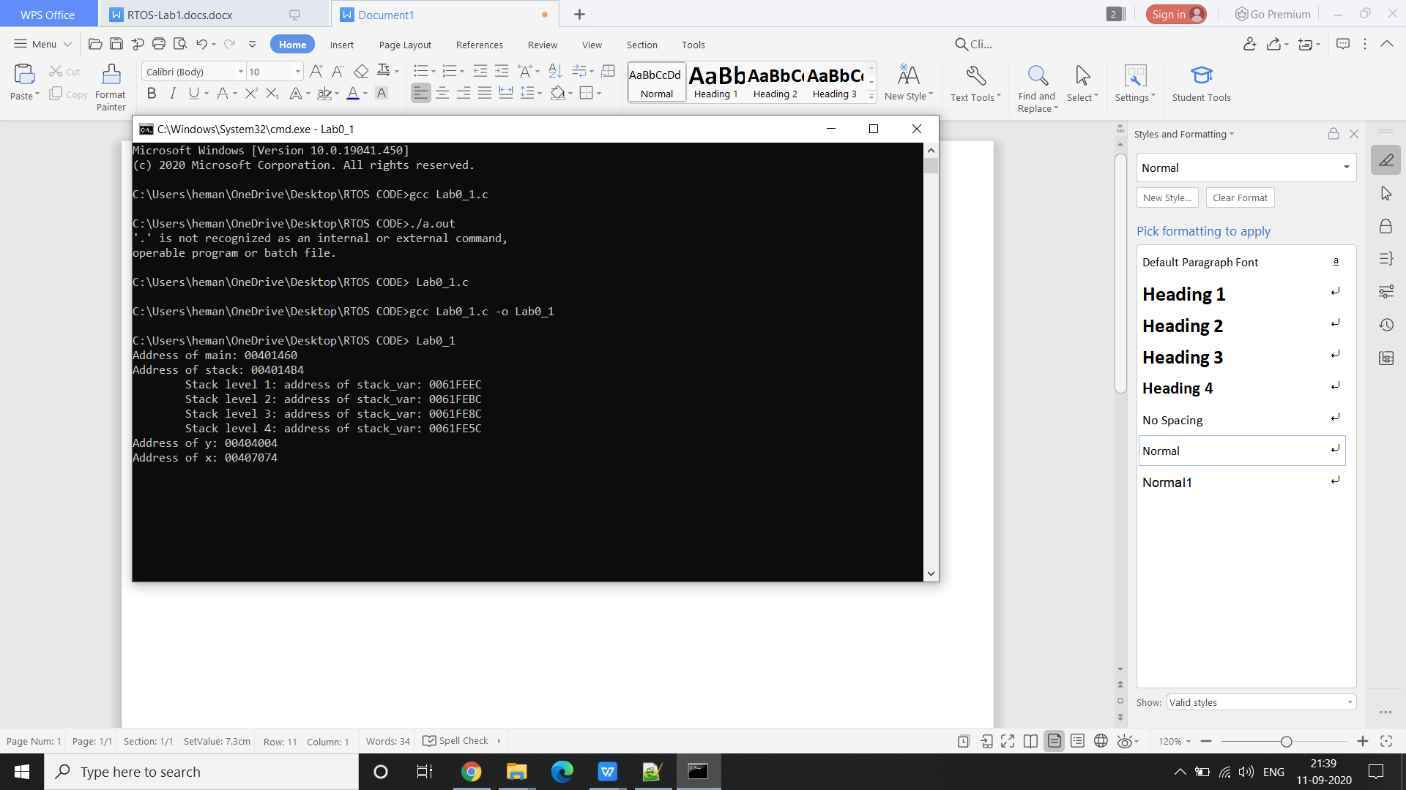

1. **Create a loop which prints a random number after a certain amount of delay. The Value of the delay will be provided by the user. The Delay function gets an interrupt whenever any key press in there.**

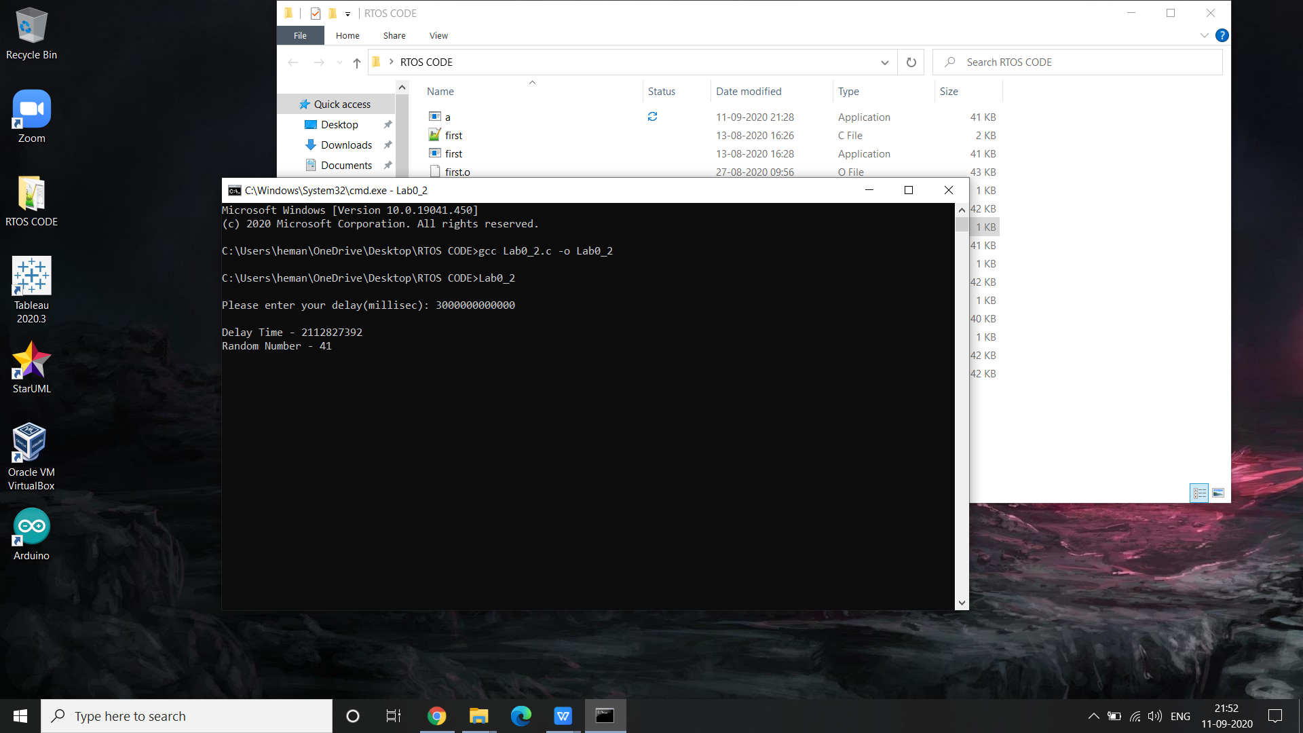

https://github.com/HemangPrakhar/RTOS_Lab_0.git